Brainstorming & Ideation
Empathy Map Canvas
Date | 12 July 2026
Team ID | SWTID-2026-4644
Project Name | Smart Lender
Phase | 1. Brainstorming & Ideation

Purpose
An empathy map builds a shared, concrete understanding of a user's experience before any solution is designed. The map below covers the Loan Applicant persona — what they say, think, do, and feel when applying for a loan — built from the applicant fields present in the dataset (income, employment type, credit history, marital status, dependents, education, and property area) combined with common lending pain points.

Empathy Map — Persona: Loan Applicant
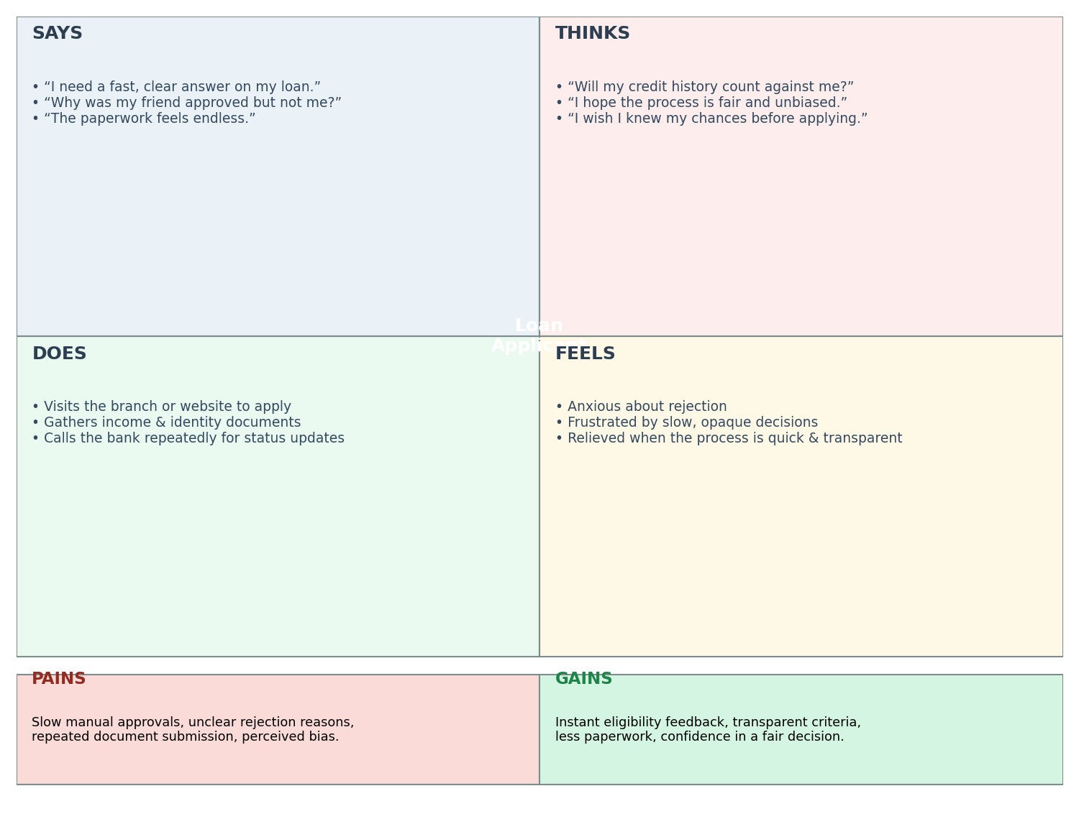
Figure 1: Empathy Map Canvas — Loan Applicant persona.

Interpreting the Map
- SAYS/THINKS quadrants reveal the applicant's core need: a fast, fair, explainable answer.
- DOES quadrant shows the current, effortful workaround: branch visits, document gathering, repeated status calls.
- FEELS quadrant shows the emotional stakes: anxiety and frustration before a decision, relief afterward — this is the moment Smart Lender's instant response is designed to shorten.
- PAINS/GAINS anchor the value proposition directly: removing slow, opaque review (pain) by delivering instant, transparent, consistent results (gain).

How This Shaped Smart Lender
The applicant's need for speed and transparency, and the pain of slow, opaque manual review, directly shaped two product decisions: (1) predictions are returned instantly through the /submit route after form submission, and (2) the result page clearly states the outcome and echoes back key details (loan amount, credit history status, property area) so the applicant can see what was evaluated, addressing the transparency gap identified in the THINKS quadrant.

